

**SCHOOL OF ADVANCED TECHNOLOGY**

**CAN302 Assignment**

|  |  |  |
| --- | --- | --- |
| Student Name | : | Rui Qiu |
| Student ID | : | 1930209 |

**Appendix**

**UI Design**

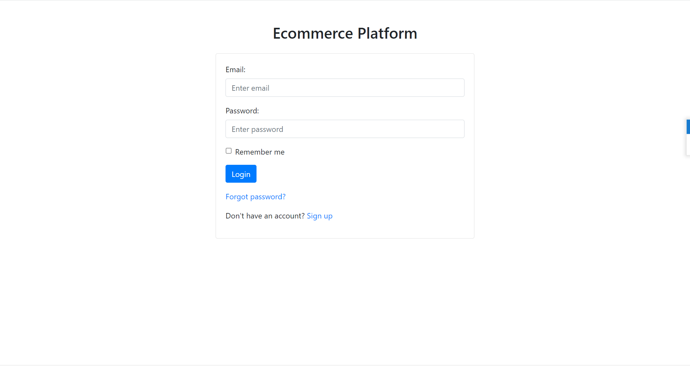

Step1. Login Page

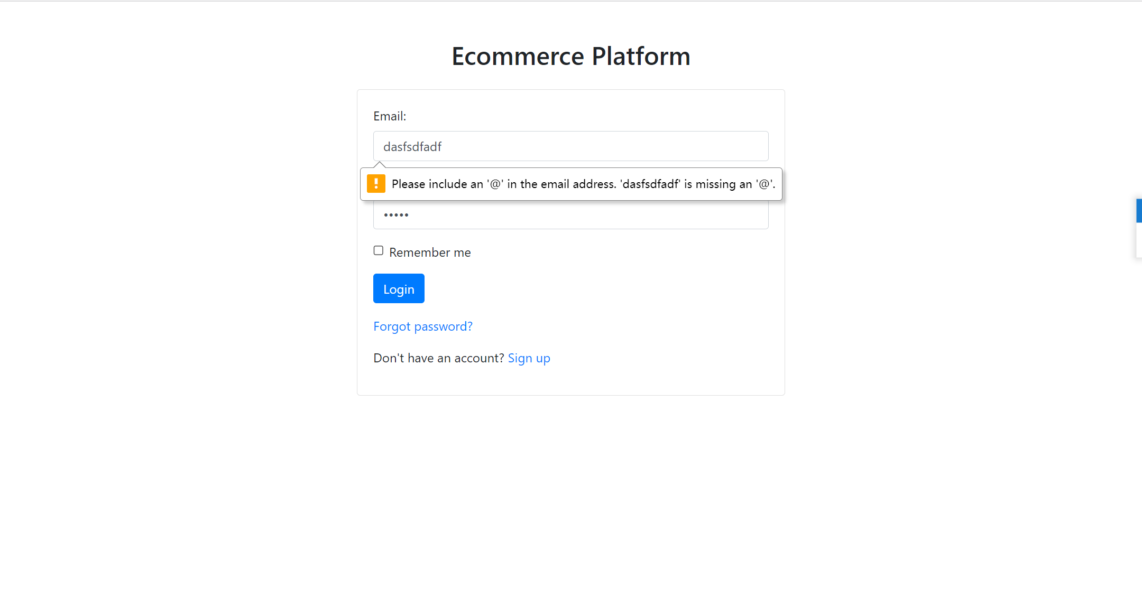

Step2. An incorrect format would not be allowed

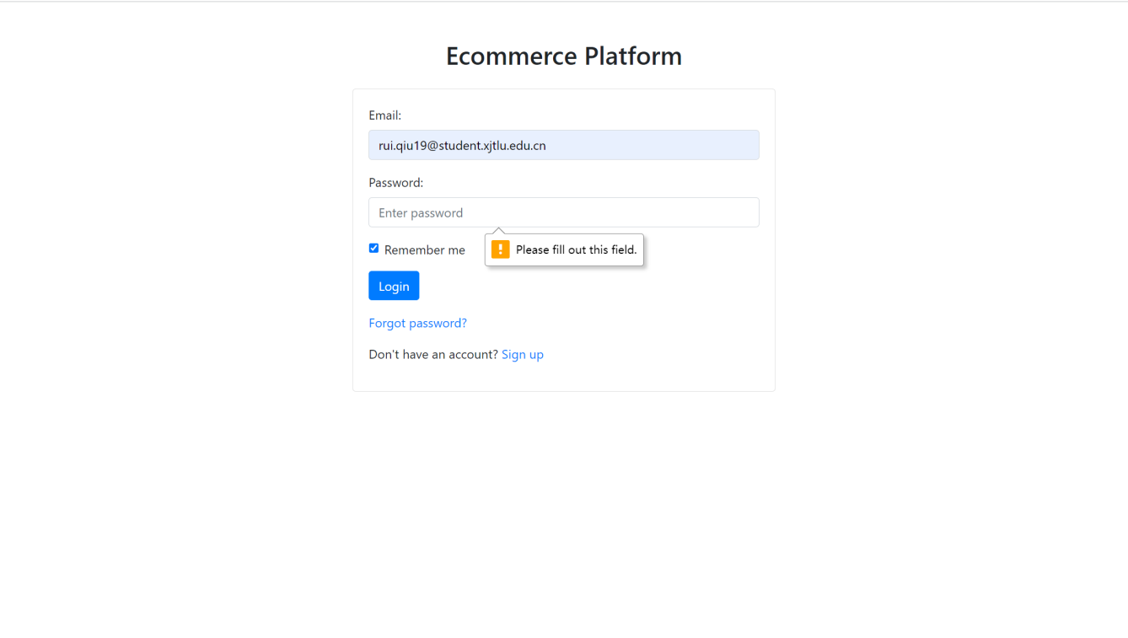

Step3. Must fill out the “Password” field

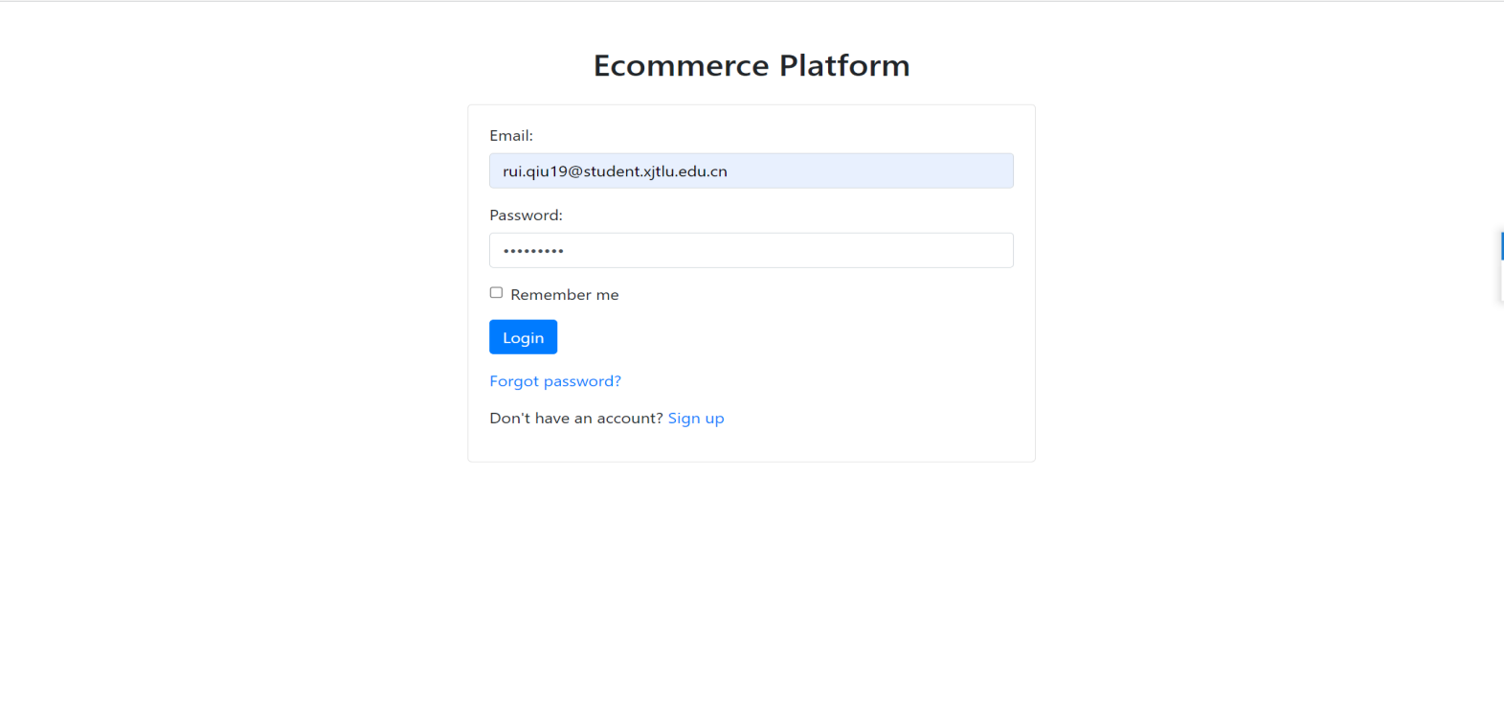

Step4. Correct user information, then click on the “Login” button.

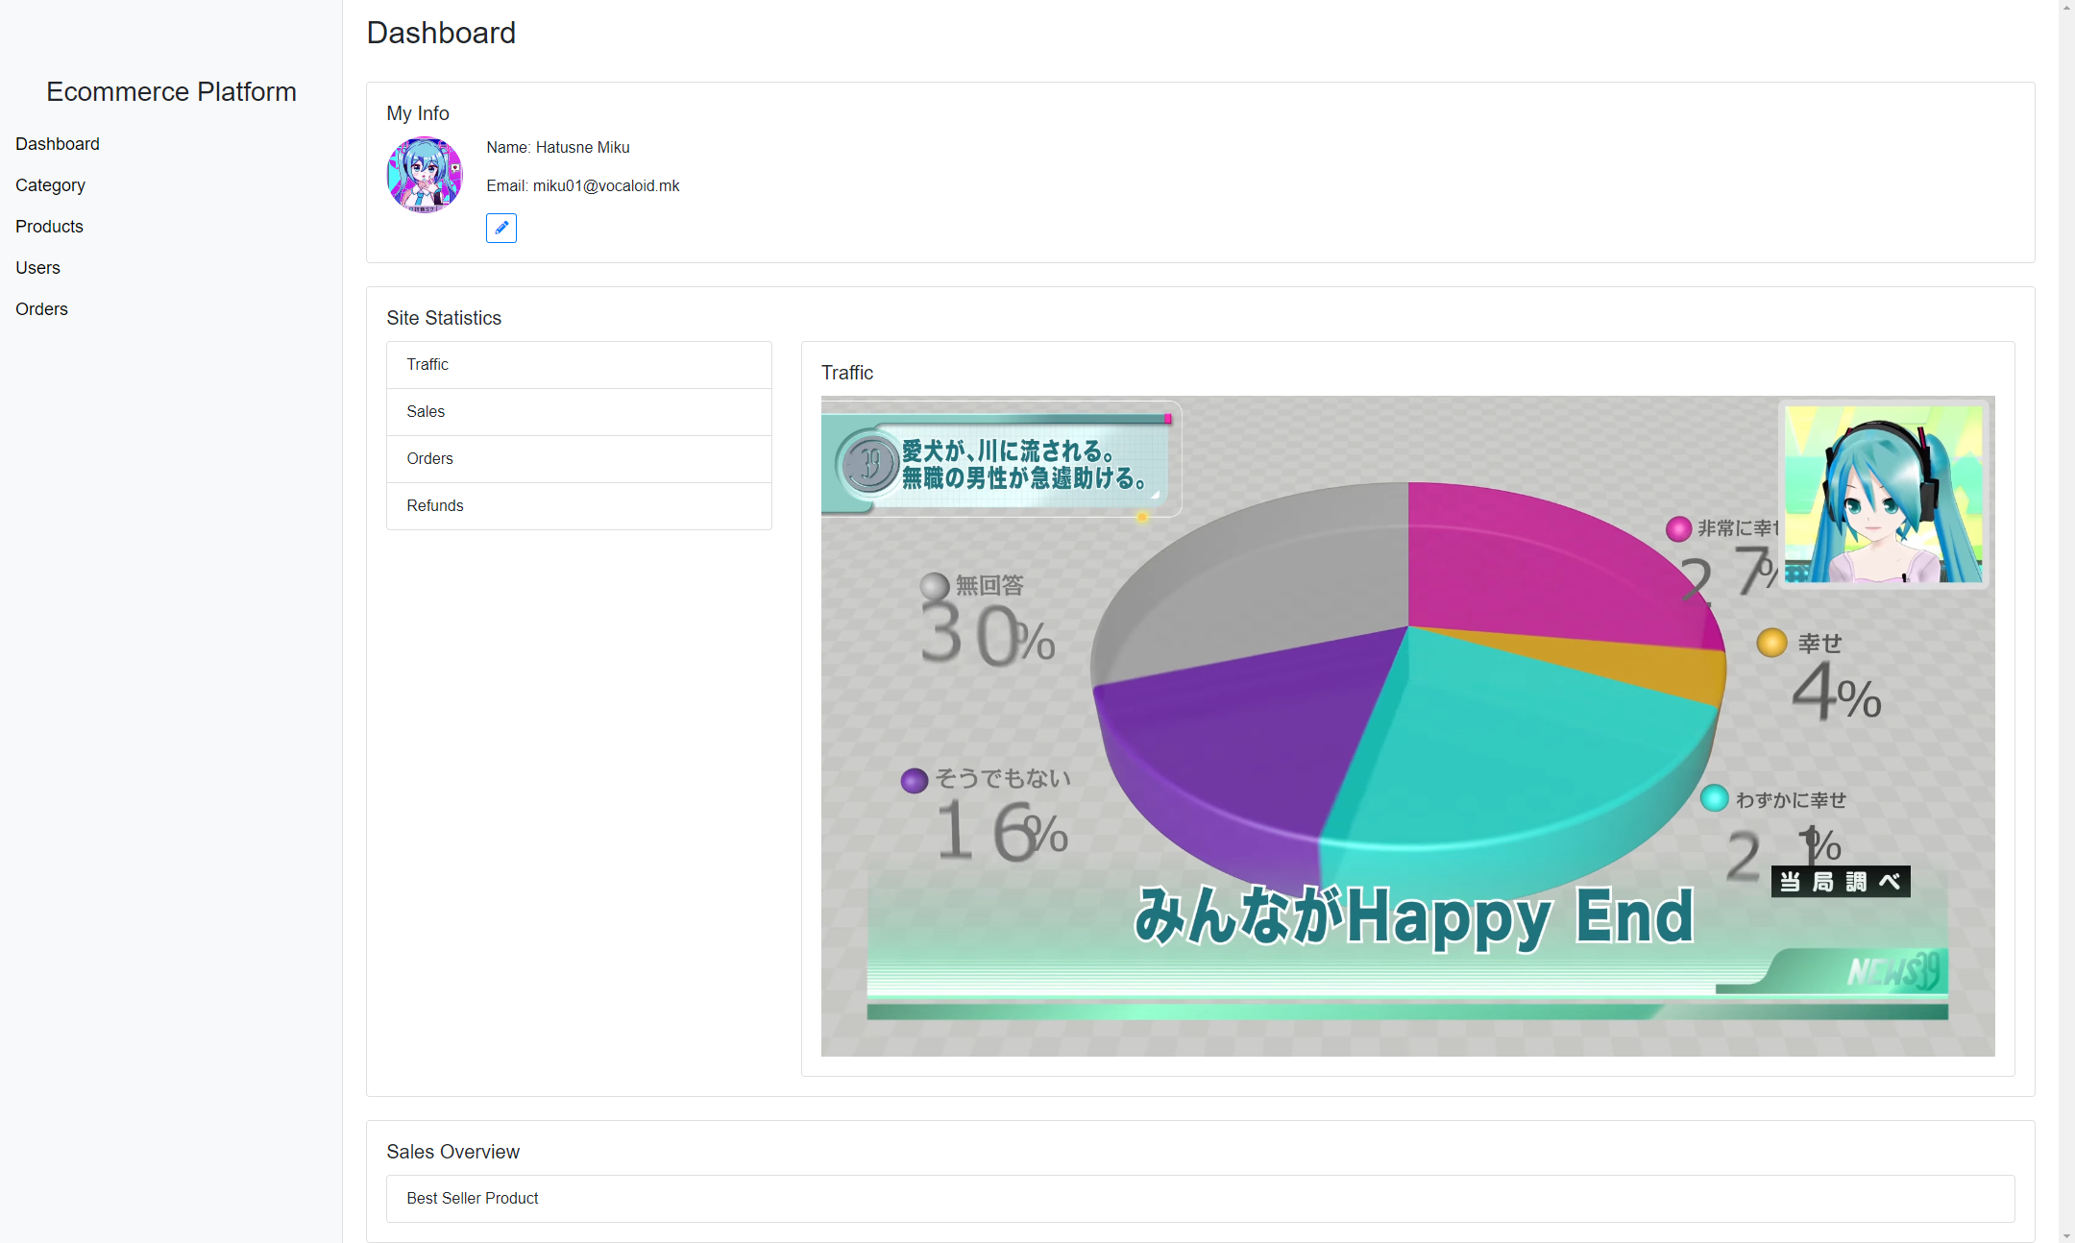

Step5. After clicking “Login”, it shows the Dashboard page. Click the “Pen” button in blue to edit the information.

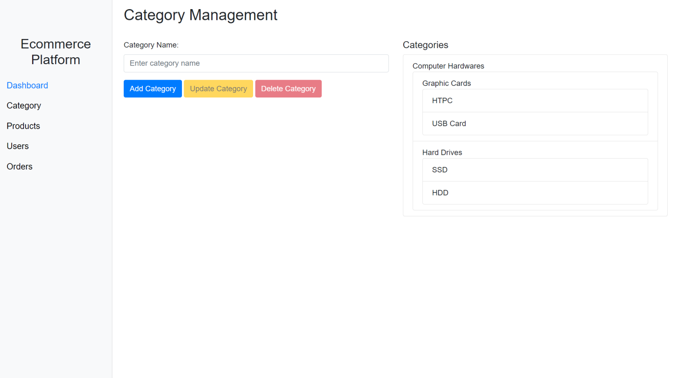

Step6. Click on the “Category” button in the menu on the left.

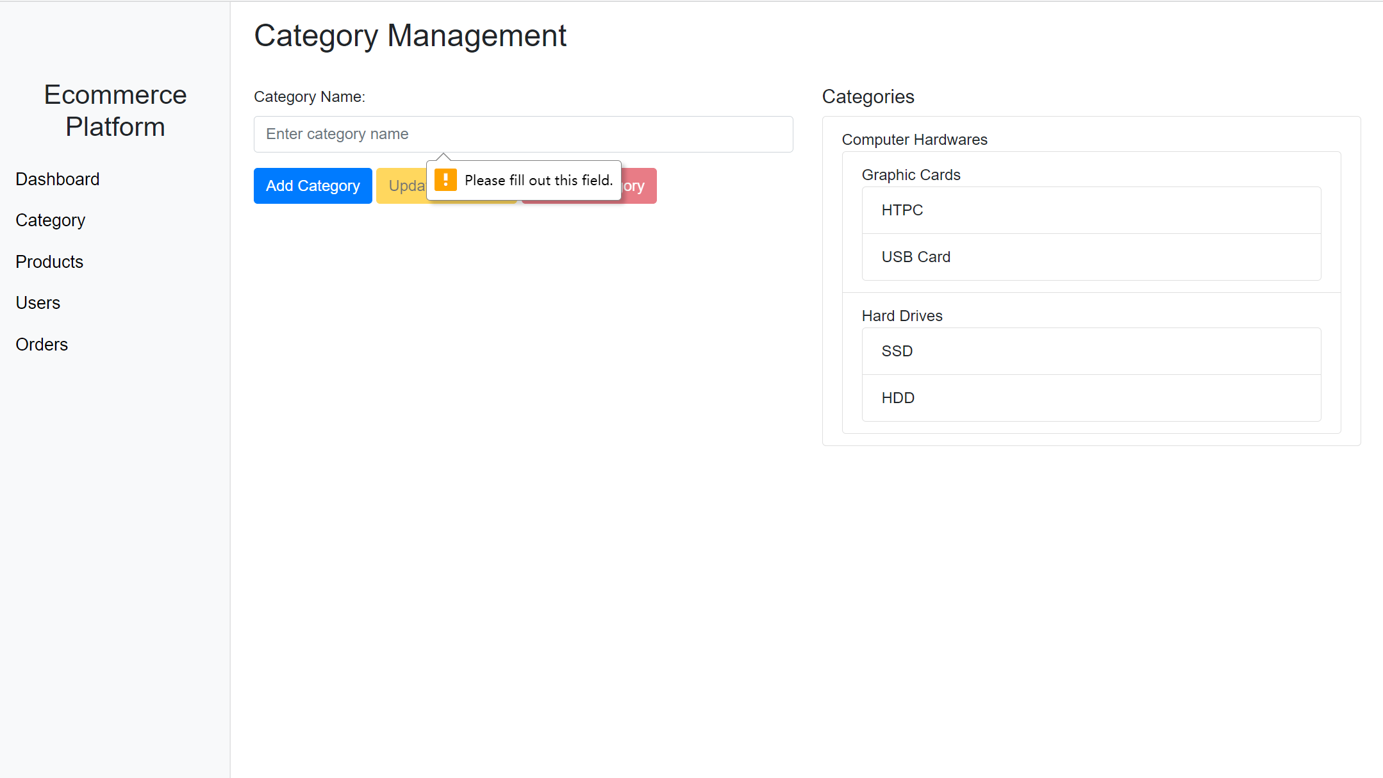

Step7. Must input the content, otherwise the system will indicate that.

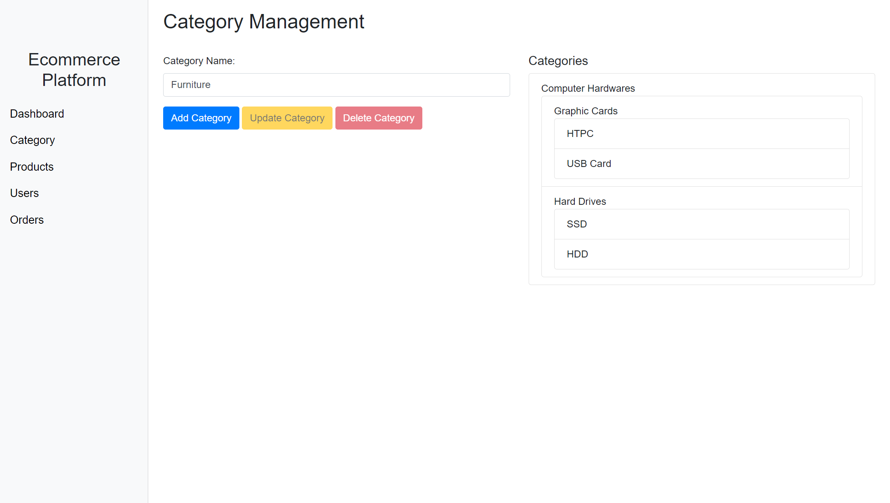

Step8. Input the category(e.g. Furniture), then click on the “Add Category” button.

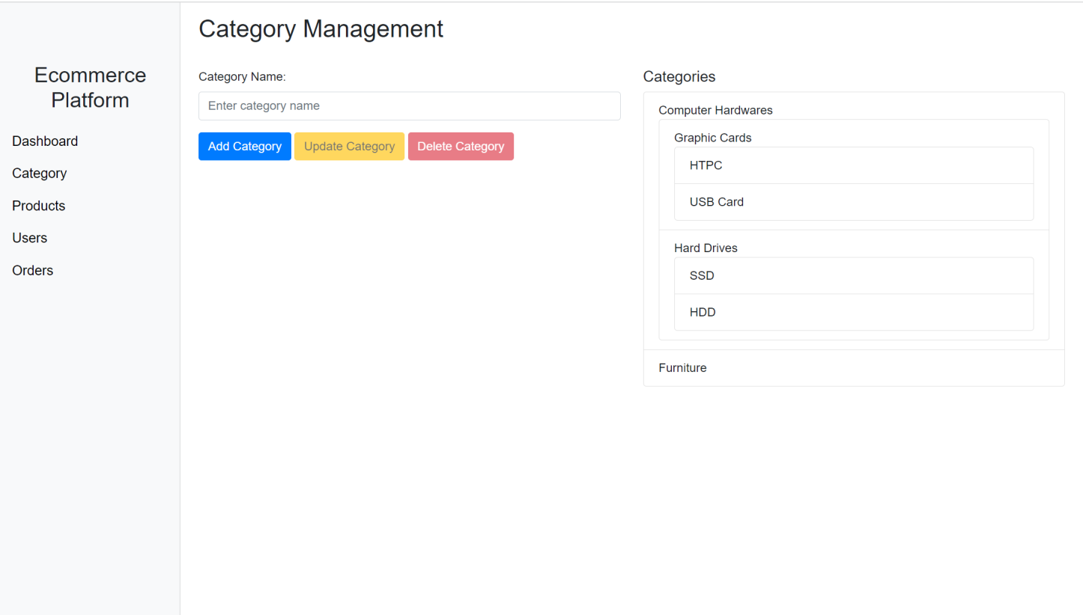

Step9. The system shows category on the right side. Click “Delete Category” to deleted it. Click “Update Category” to update it.

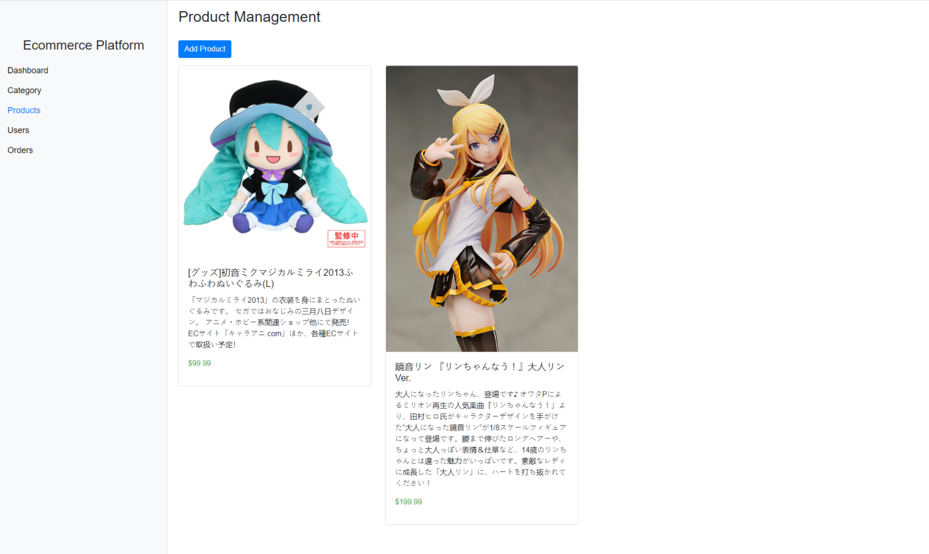

Step10. Click “Products” in the menu, it shows the “Product Management” page.

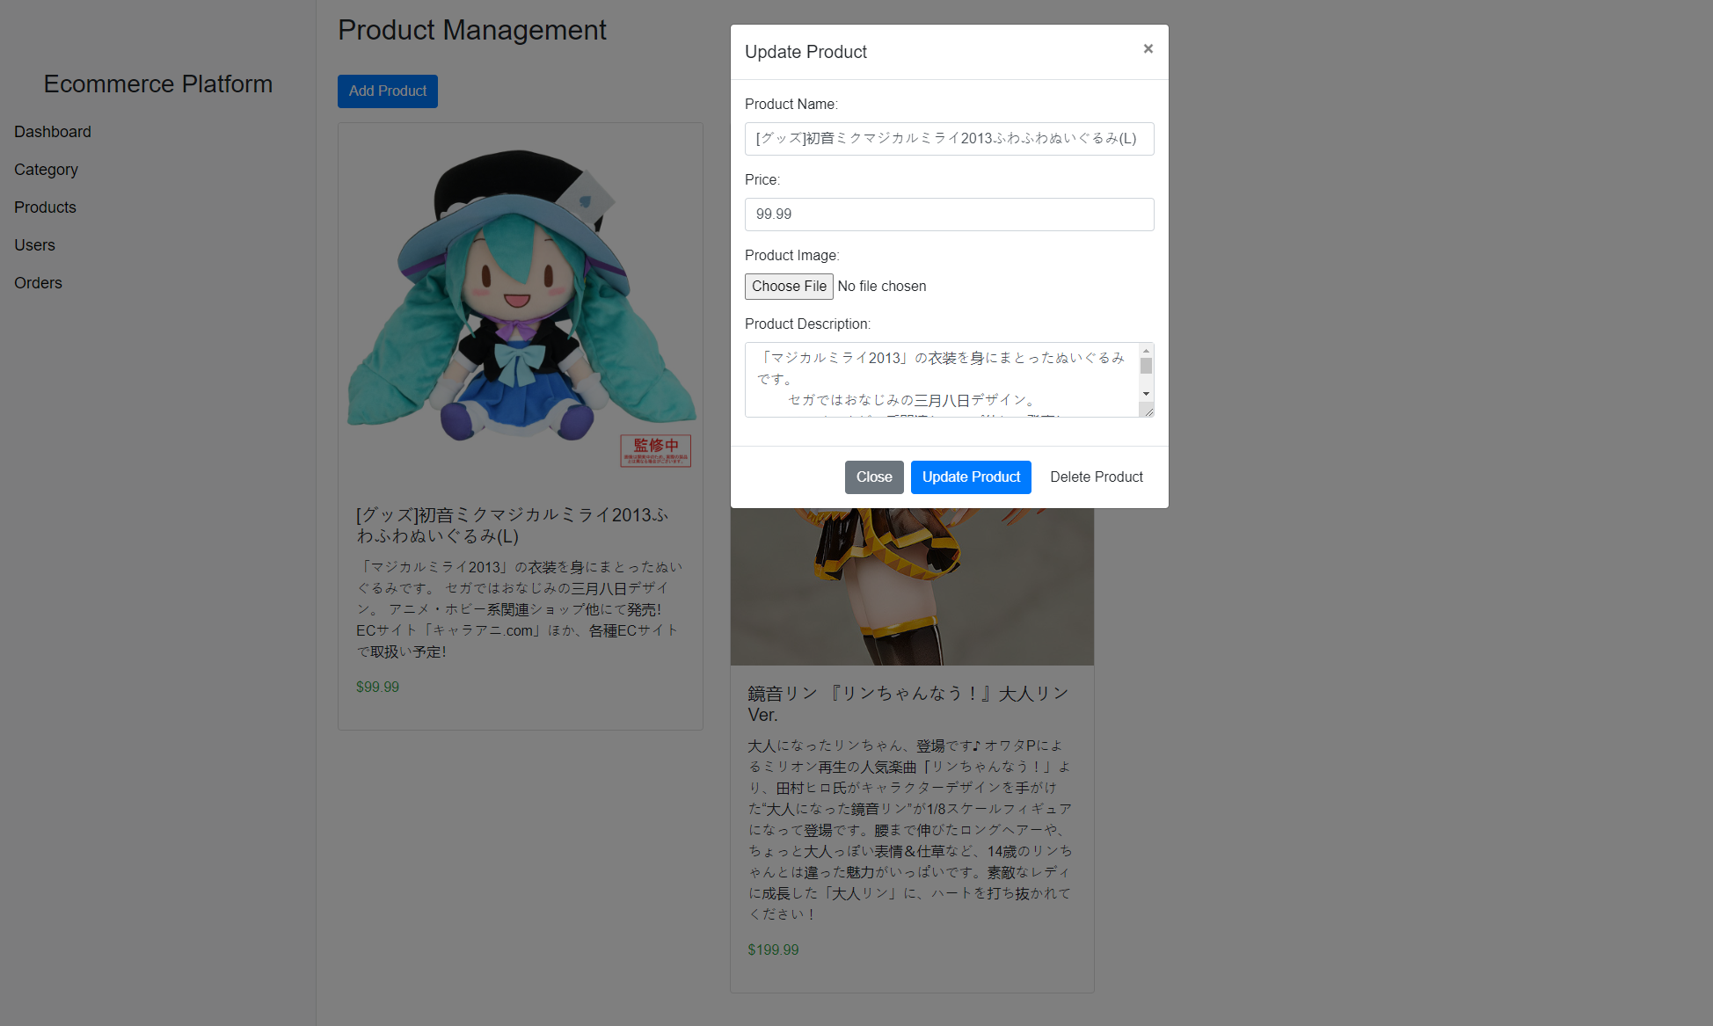

Step11. Click the certain product, alter the information of product, then click “Update Product”, successfully edit, or click “Close”, stop altering.

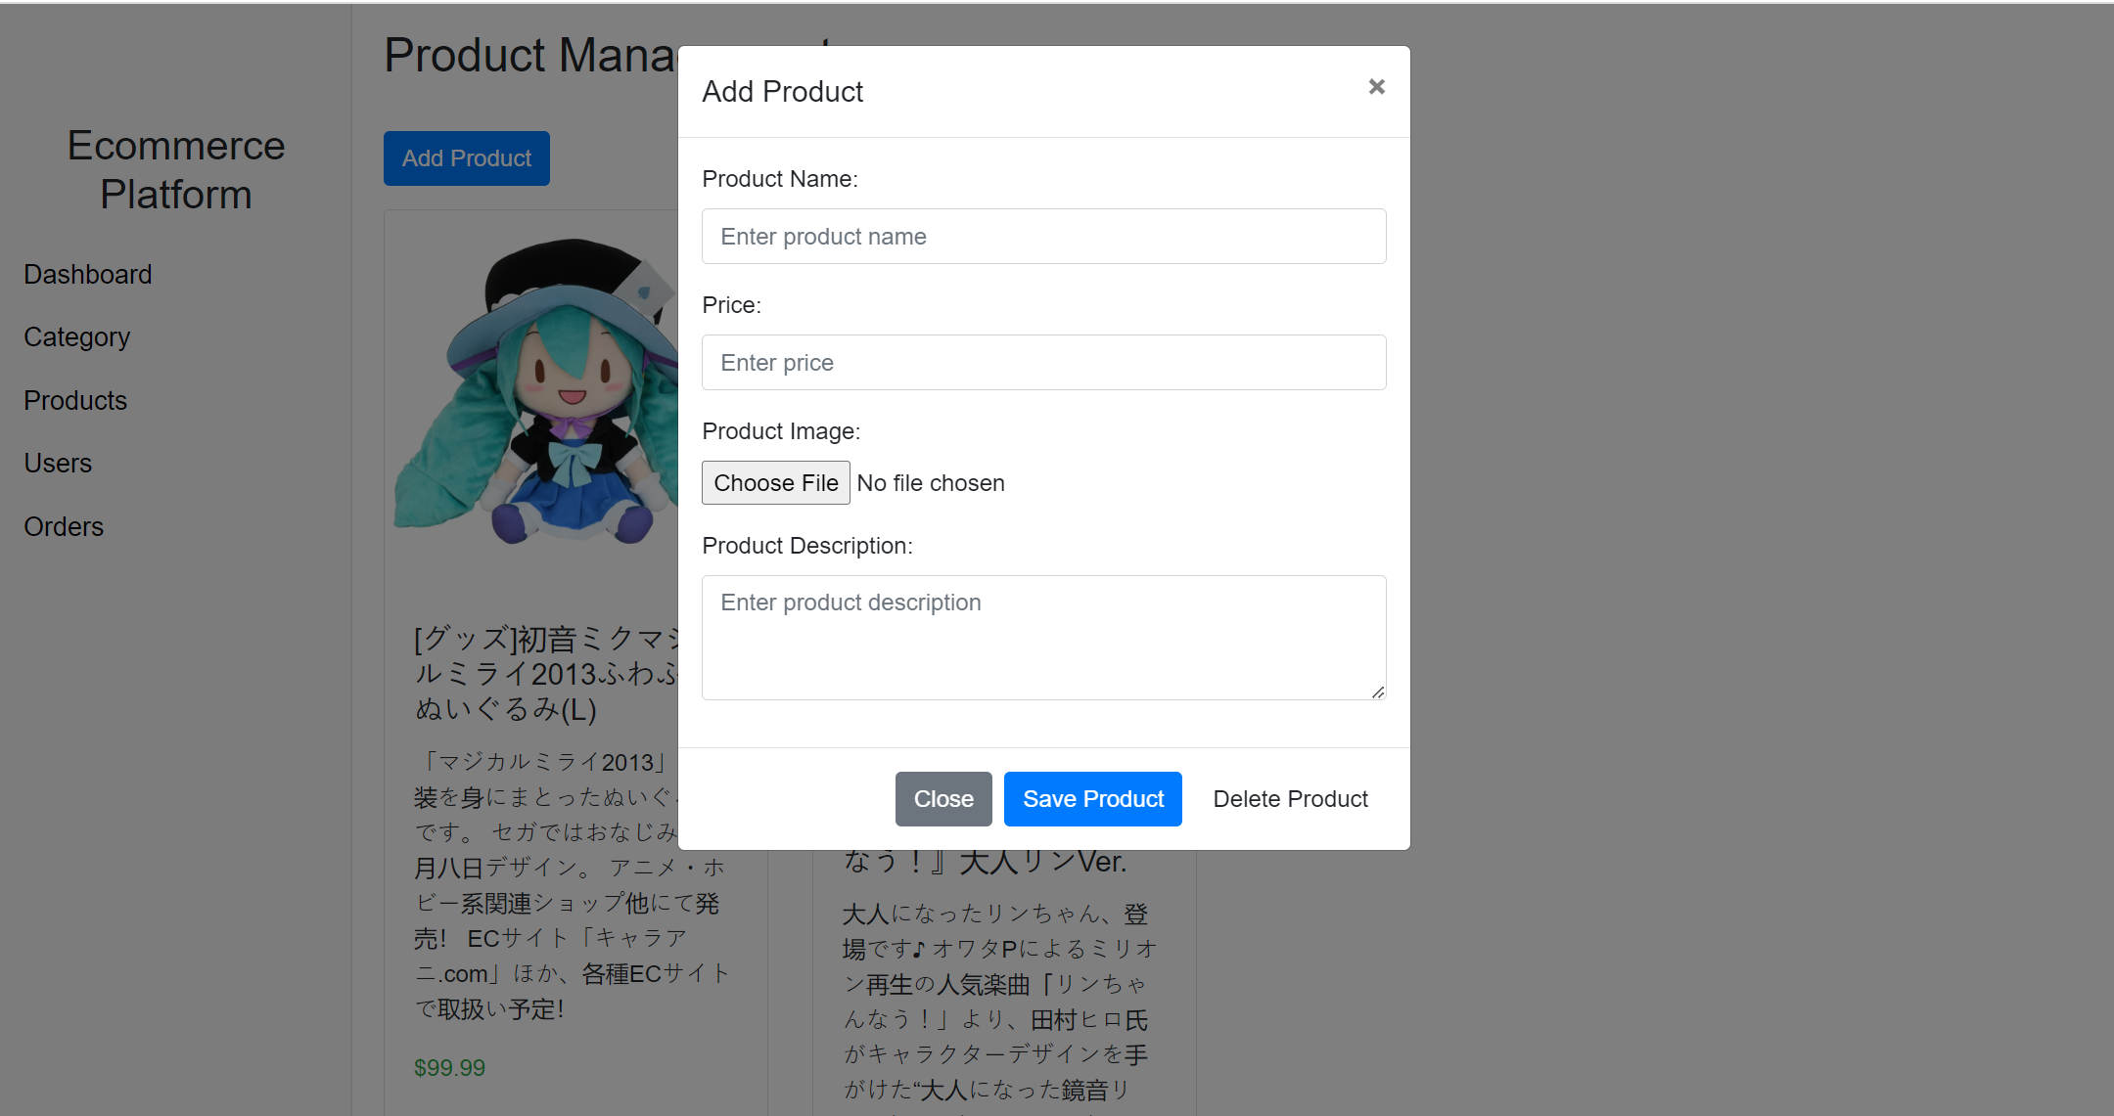

Step12. Click “Add Product”

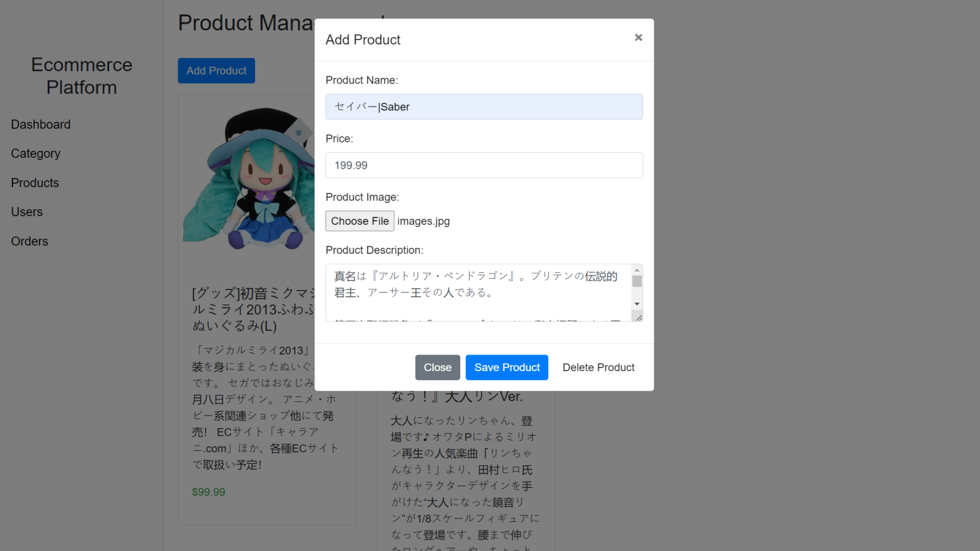

Step13. Add the information of the product, click “Save Product”

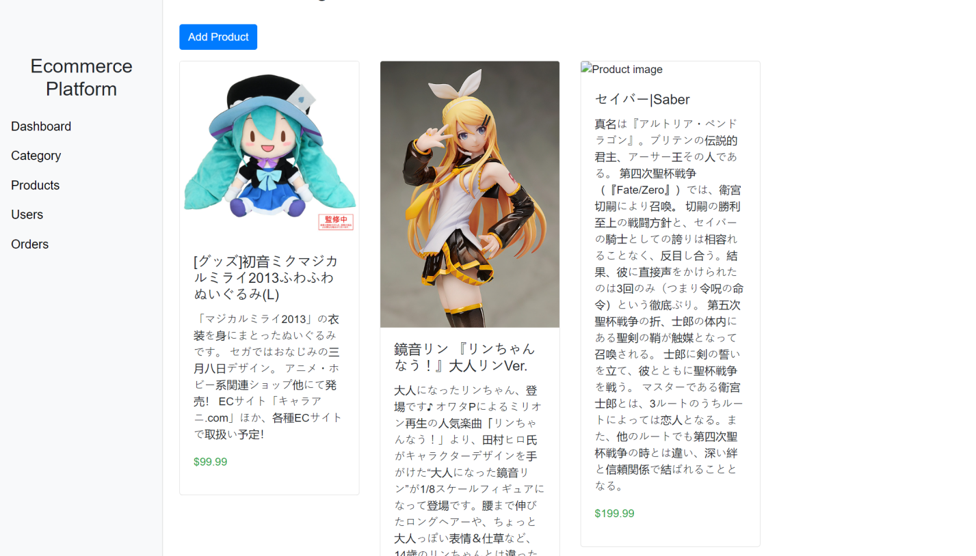

Step14. The new product is showed on the “Products” page

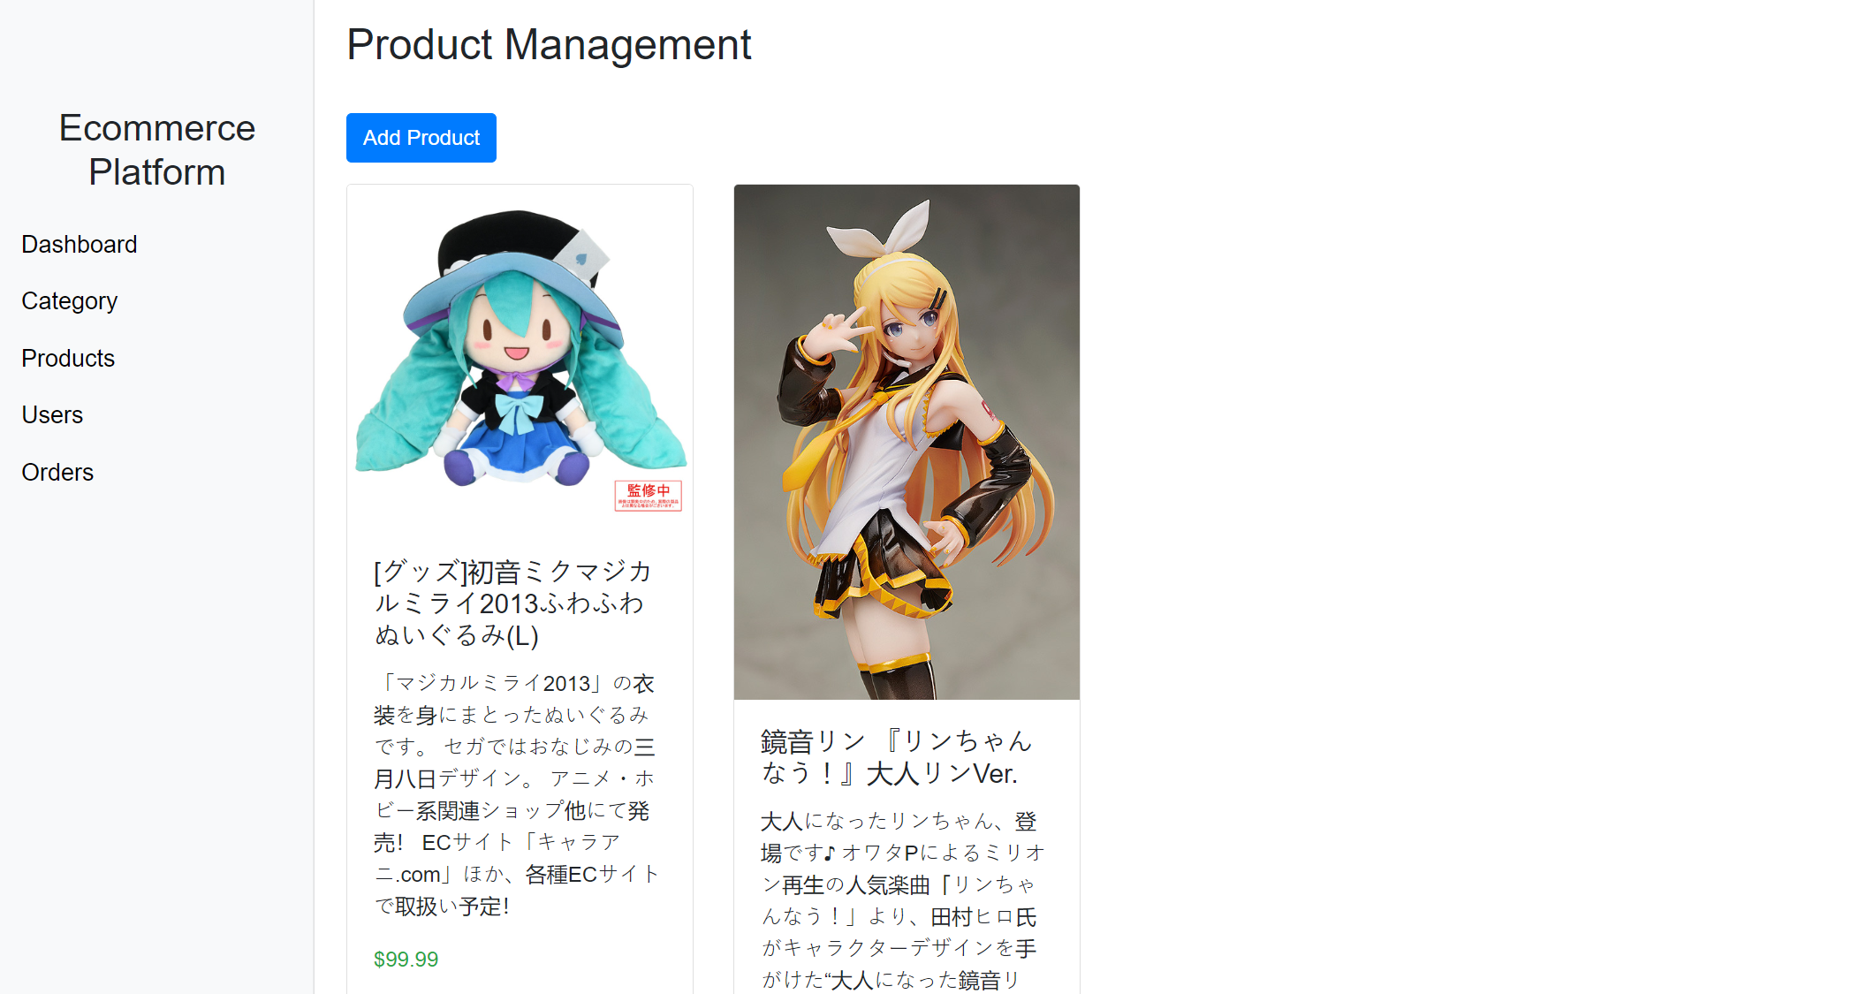

Step15. Click the new product, choose “Delete Product”, the certain product will be deleted.

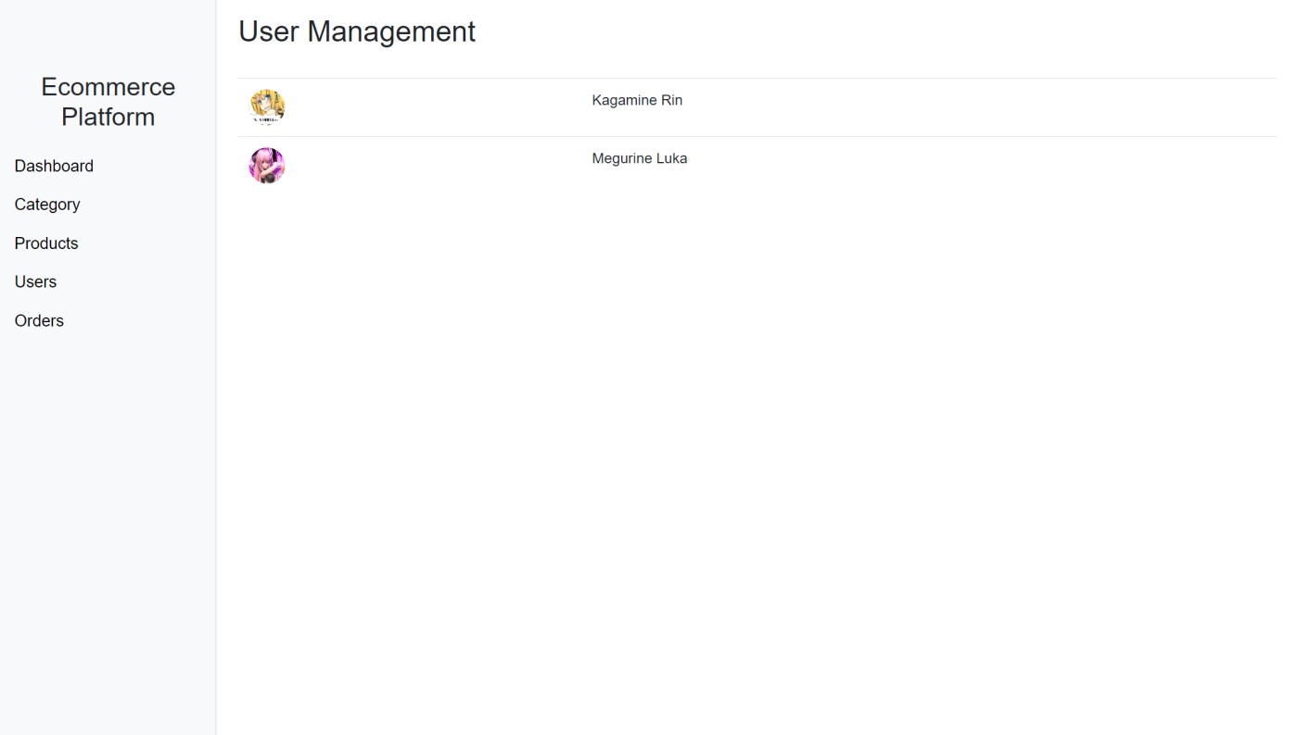

Step16. Click on the “Users” button on the left, it shows the “User Management” page

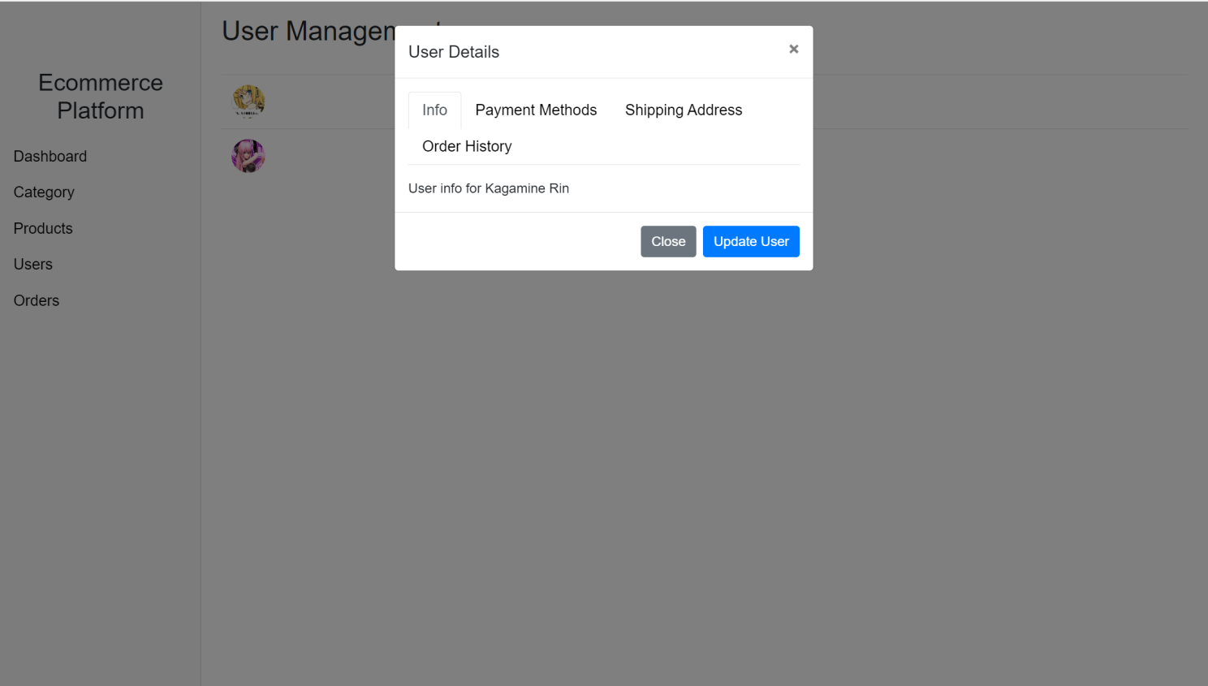

Step17. Click the certain user, it shows “User Details”. Click “Close” to stop altering

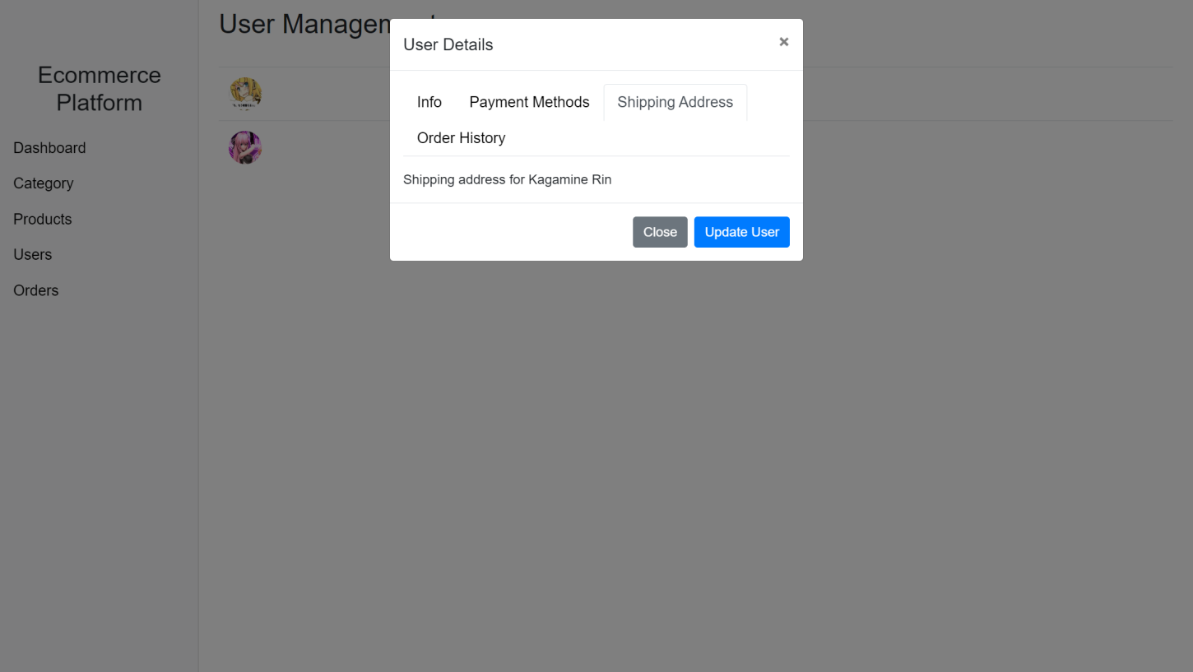

Step18. Update Shipping Address, click “Update User”, the shipping address is successfully updated

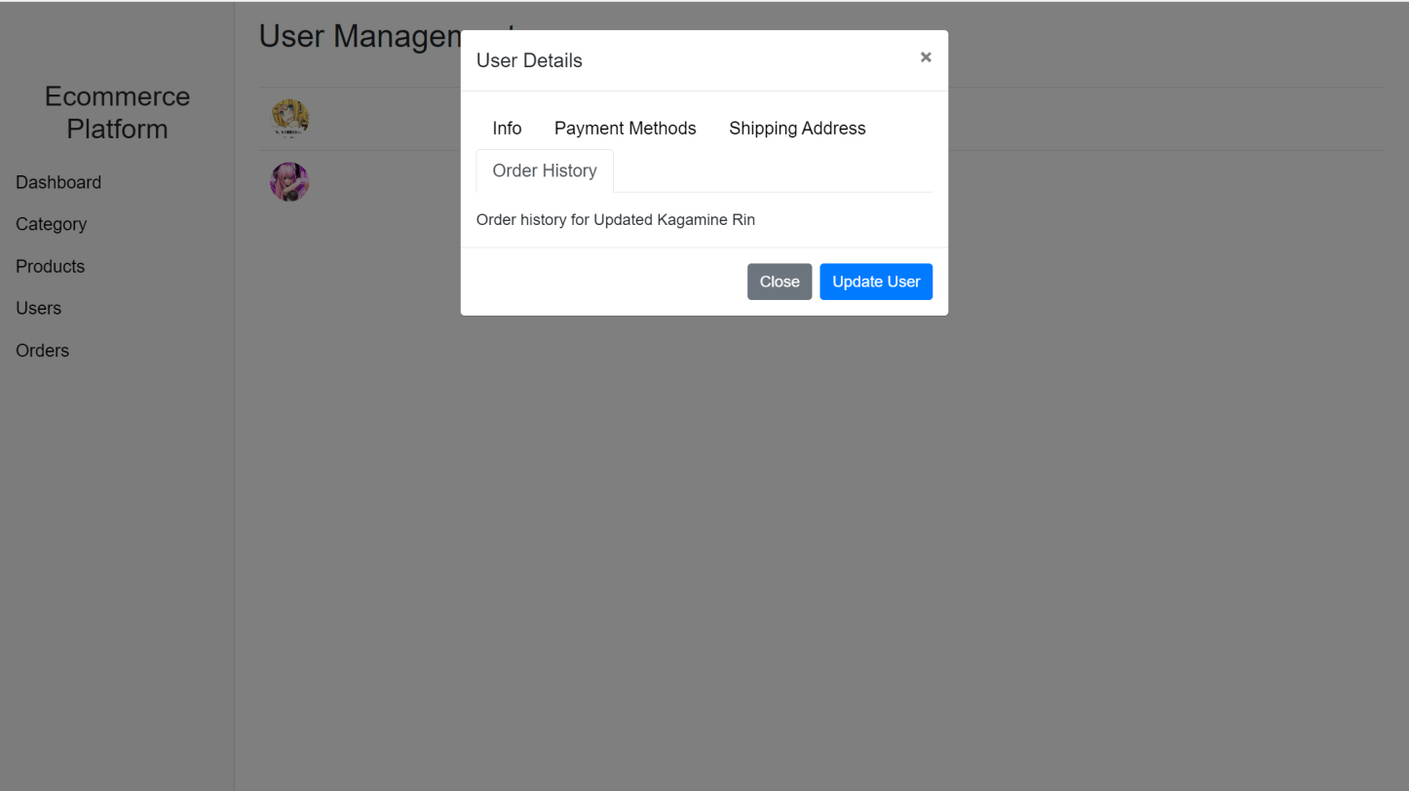

Step19. Update Order History, click “Update User”, the Order History is successfully updated

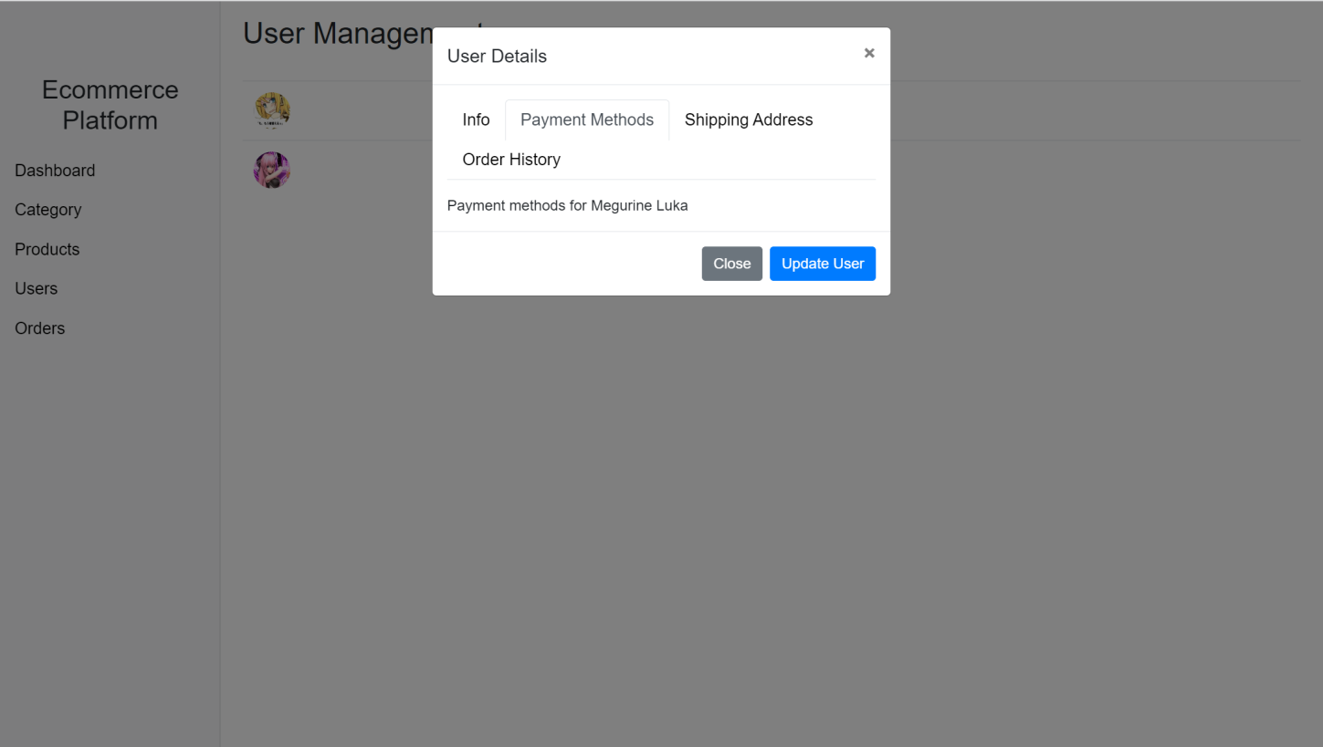

Step20. Update Payment Methods, click “Update User” to alter it successfully

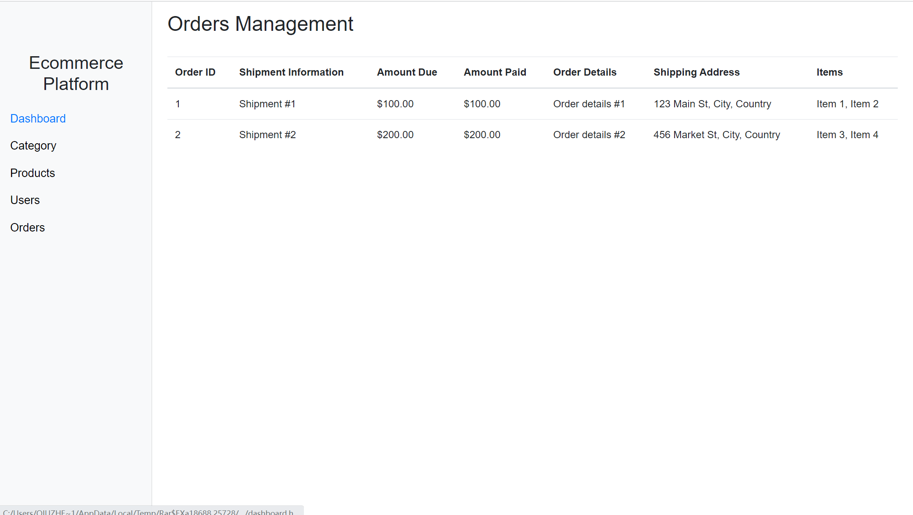

Step21. Click “Orders” button in the menu, it shows “Orders Management” page.

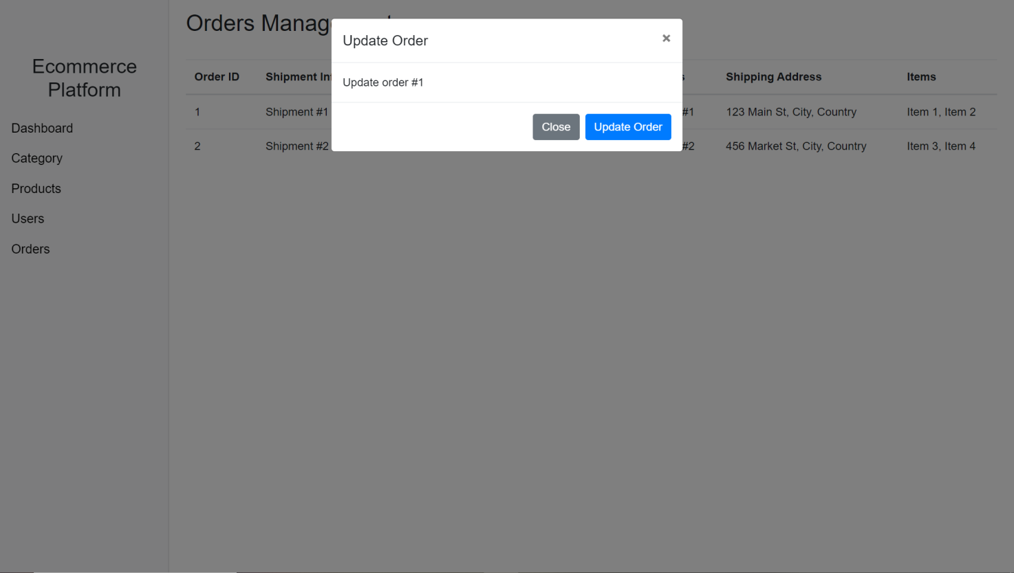

Step22. Click on a certain Shipment order. Click “Update Order” to successfully updated it. Click “Close” to stop edition.

**Database Structure**

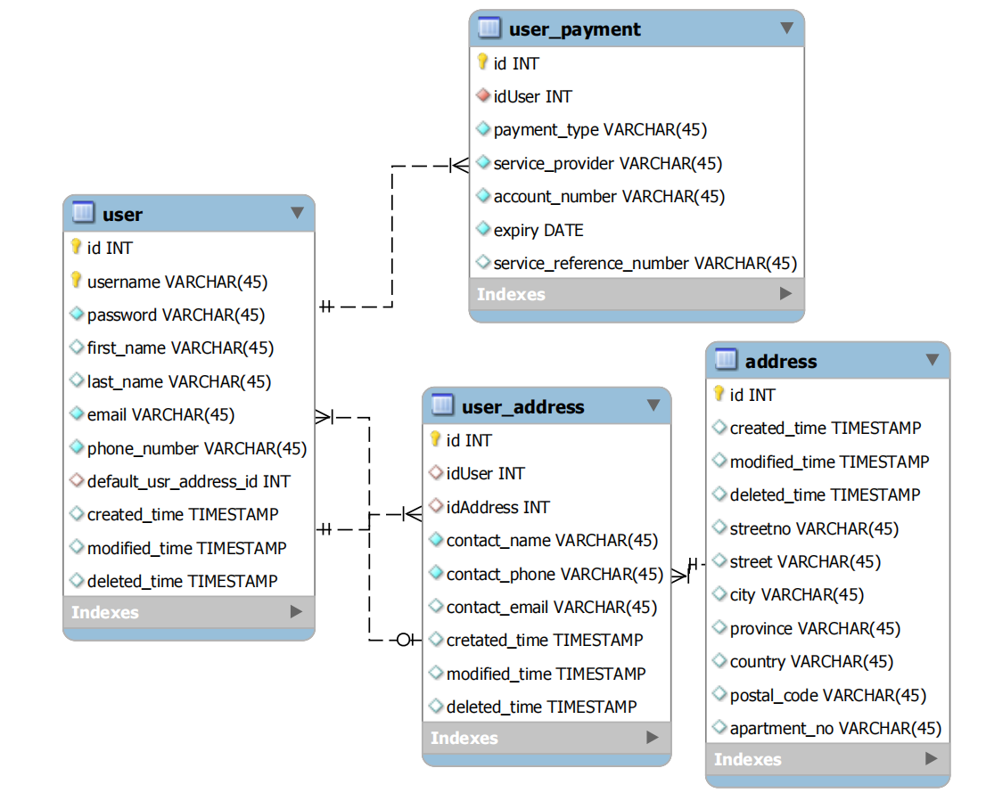

Figure1. User Management

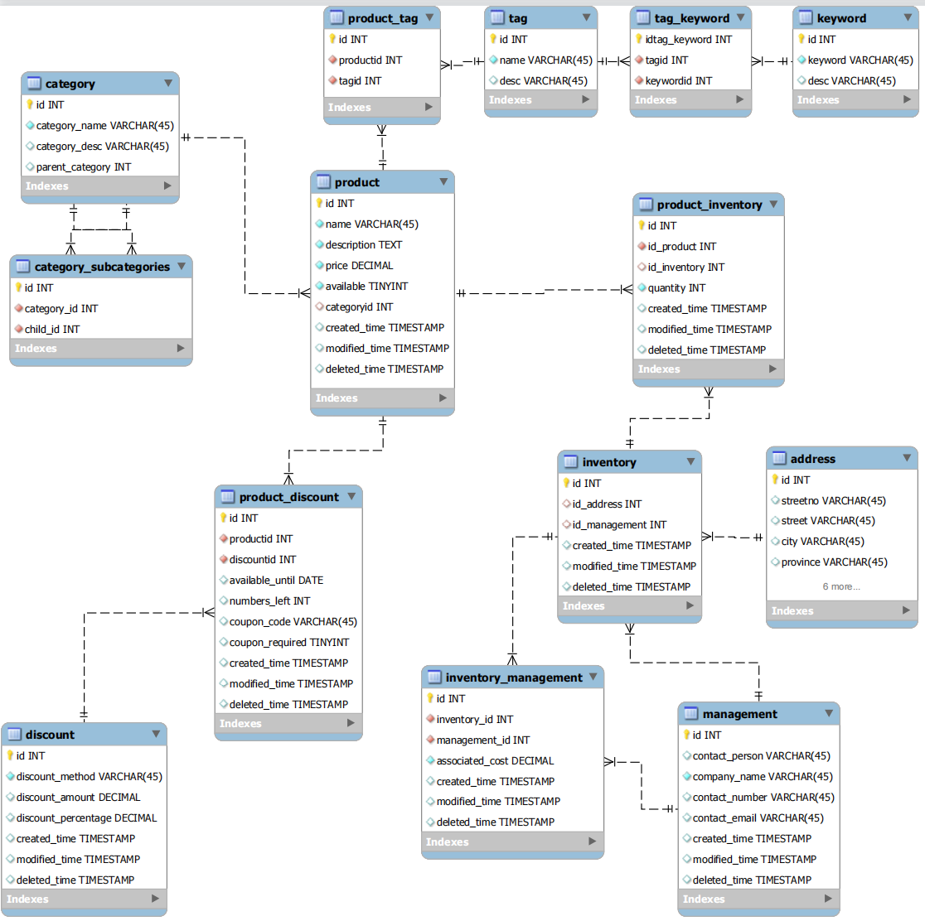

Figure2. Product Management

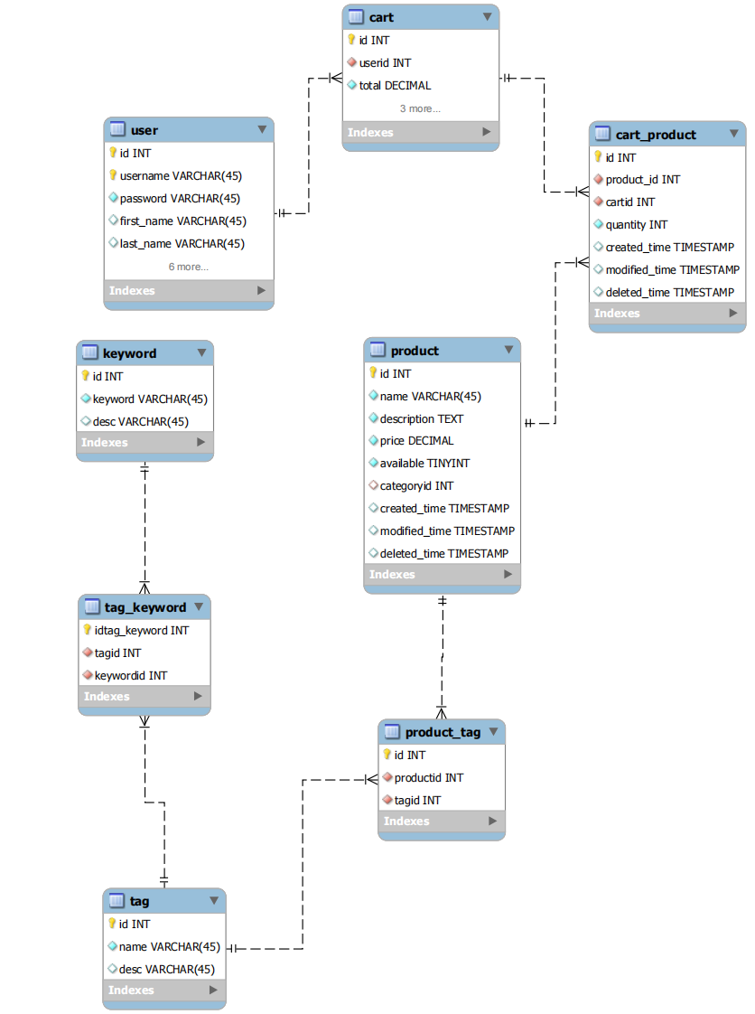

Figure3. Shopping Process

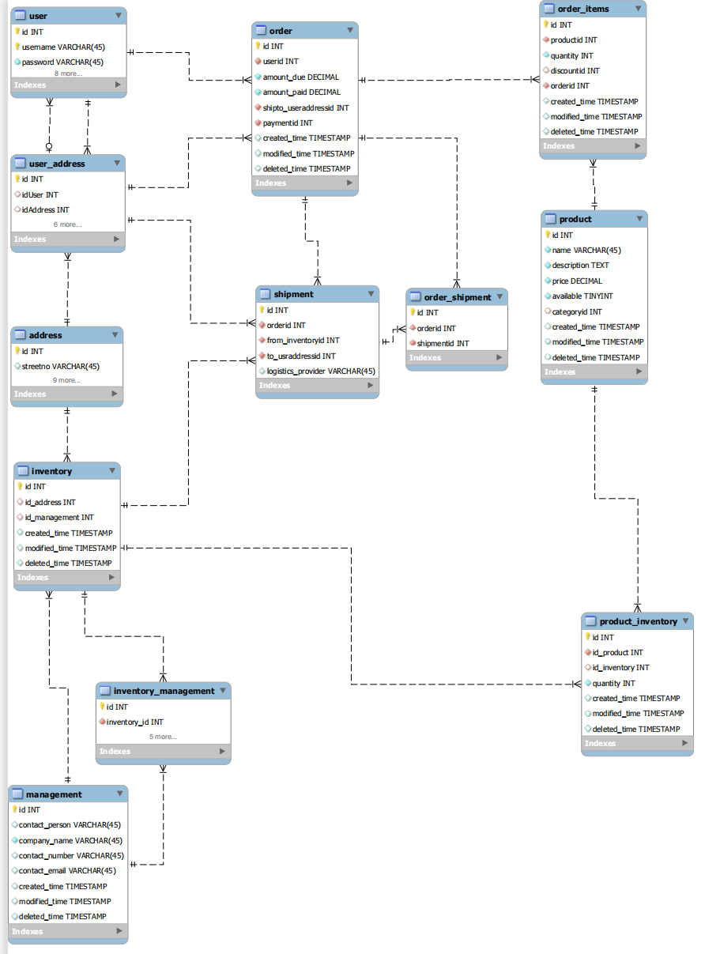

Figure4. Order Shipment

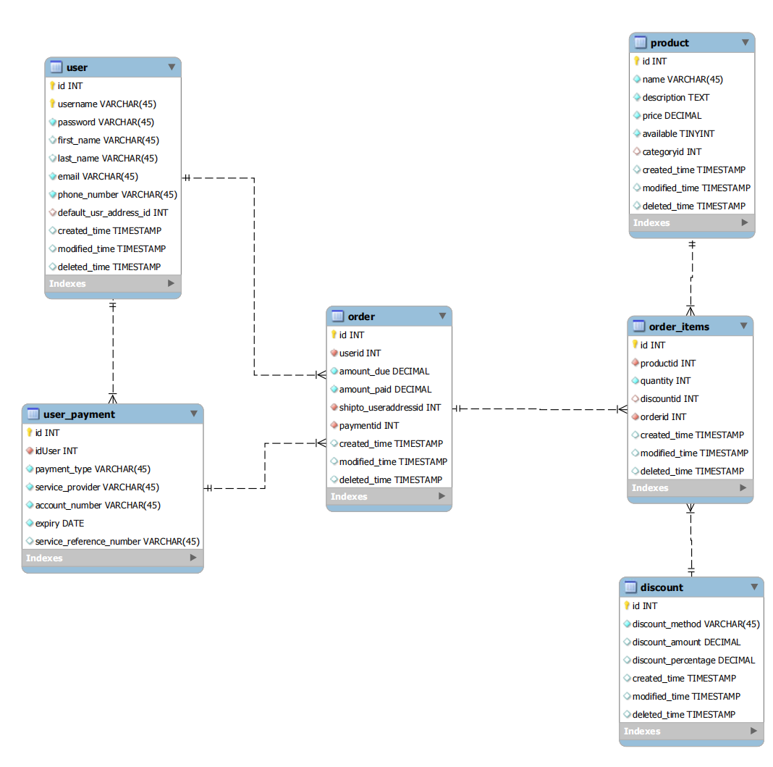

Figure5. Order Payment